
EXPLAINABLE MACHINE LEARNING FRAMEWORK
FOR EARLY HEART DISEASE PREDICTION
PROJECT PROPOSAL / DOCUMENTATION
Group-8
2420030503 – Katta Anoop
2420030490 – V. Sree
2420030582 – Sameera.M
2420030537 – Souraja.M

1. Project Title
Explainable Machine Learning Framework for Early Heart Disease Prediction

2. Problem Statement
Heart disease is a major healthcare challenge, and early identification of high-risk patients can support timely clinical attention. Machine learning can learn patterns from patient health data and provide risk predictions, but many high-performing models are difficult to interpret. A prediction such as “high risk” does not by itself tell a healthcare professional which patient characteristics influenced the decision. This black-box behaviour can reduce trust and make machine learning harder to use as a decision-support tool.
The proposed project will therefore build an explainable machine learning framework that combines predictive modelling with patient-level and global explanations. Multiple classification models will be compared, the best model will be selected using standard evaluation metrics, and SHAP and LIME will be used to explain the model’s decisions. The system is intended as an academic decision-support prototype, not a replacement for medical diagnosis.

3. Objectives
- Develop a machine-learning framework for early heart disease risk prediction.
- Collect, clean, explore and preprocess structured heart disease data.
- Train and compare Decision Tree, Random Forest, Logistic Regression, XGBoost and SVM.
- Evaluate models using accuracy, precision, recall, F1-score, ROC-AUC and confusion matrix.
- Select the best-performing model considering performance, robustness and interpretability.
- Integrate SHAP for global feature importance and local contribution analysis.
- Integrate LIME for understandable patient-level explanations.
- Present risk prediction, probability, important factors and explanations through a dashboard.
- Use cross-validation and, where feasible, an additional public dataset for robustness testing.

3.1 Proposed Model / Framework to be Built
The framework will contain five connected layers:
- Data layer – public heart disease datasets such as UCI/Cleveland and selected additional datasets.
- Preprocessing layer – cleaning, missing-value handling, encoding, scaling, class-balance analysis and EDA.
- Prediction layer – Decision Tree, Random Forest, Logistic Regression, XGBoost and SVM.
- Explainability layer – SHAP for global/local feature contributions and LIME for local patient explanations.
- Decision-support layer – dashboard showing prediction, probability, important features and explanation plots.
- Validation layer – stratified cross-validation, hold-out testing, ROC-AUC and robustness checks.

4. Literature Survey
The following table summarizes 11 recent and representative studies. Dataset links are provided where a public repository is identified. Where a dataset is private or only available on request, this is stated.

No. | Research Paper Title | Model / Method | Outcome | Limitations | Dataset Used | Dataset Link
1 | Interpretable Machine Learning Model For Heart Disease Prediction | 2023 | SVM, RF, XGBoost, KNN + SHAP + LIME | SVM and XGBoost reached F1 up to about 88%; SHAP identified important variables and LIME explained individual classifications. | Benchmark-data scope limits generalization; post-hoc explanations depend on the model and data. | Open dataset
2 | Integrating explainable machine learning and user-centric model for diagnosing cardiovascular disease: A novel approach | 2024 | DT, KNN, RF, XGB + SHAP + interface | Four classifiers were tested; KNN reported 71% accuracy and SHAP explanations were embedded in a diagnostic interface. | Modest predictive performance; dataset is available on request; further clinical validation is needed. | Not public / on request
3 | A proposed technique for predicting heart disease using machine learning algorithms and an explainable AI method | 2024 | SMOTE + multiple ML models + XGBoost + SHAP | XGBoost achieved 97.57% accuracy and 98% AUC on the combined/SF-2 setup; SHAP explained predictions. | Cleveland plus private data limits availability/representativeness; class imbalance and domain adaptation remain concerns. | Open dataset
4 | Explainable AI-driven machine learning for heart disease detection using ECG signal | 2024 | RF/XGBoost + DWT/EWT + SHAP | EWT+XGBoost achieved strong AUCs across PhysioNet 2016, PASCAL and MIT-BIH datasets. | Signal-focused pipeline is complex; extensive preprocessing/feature extraction is required; broader clinical validation is needed. | Open dataset
5 | HXAI-ML: A hybrid explainable artificial intelligence based machine learning model for cardiovascular heart disease detection | 2025 | Hybrid balancing + Extra Trees + SHAP/LIME/PIA | Reported 98.78% accuracy on Cleveland and 99.24% on Framingham using hybrid balancing and Extra Trees. | Complex multi-stage pipeline; benchmark dependence and broader multi-centre validation remain limitations. | Open dataset
6 | Ensemble learning approach with explainable AI for improved heart disease prediction | 2025 | IELF: EBM + XGBoost + SHAP + LIME | Evaluated Cleveland and Framingham with cross-validation, calibration and explanation-stability analysis. | Cleveland is small and Framingham is dated in demographic diversity; external validation is required. | Open dataset
7 | SmartHeart: A conceptual framework for explainable machine learning in cardiovascular risk prediction | 2025 | RF and other ML + SHAP/LIME + conceptual IoT | RF achieved about 92.9% accuracy and 97.1% AUC on 1,190 records; patient-level explanations and fairness analysis were explored. | Uses a pre-merged benchmark dataset; real-time IoT component is conceptual; broader validation is future work. | Open dataset
8 | An explainable machine learning framework for cardiovascular risk prediction using structured health data | 2026 | Logistic Regression, RF, Gradient Boosting + SHAP | Used about 70,000 records; ensemble methods slightly outperformed LR and SHAP identified influential predictors. | Integrated data sources may differ in population and feature behaviour; explanation consistency and external validation remain important. | Open dataset
9 | Sustainable and interpretable heart disease prediction: a clinical decision support approach for biomedical healthcare applications | 2026 | 1D CNN + LIME + SHAP | Reported 98.05% accuracy on Cleveland/Kaggle and used LIME/SHAP for interpretability. | Single-source historical data limits generalization; demographic bias, lack of prospective validation and deployment challenges remain. | Open dataset
10 | Explainable soft-voting classifier for heart disease prediction using SHAP and LIME | 2026 | Soft Voting: RF + DT + SVM + SHAP + LIME | Using 14 selected features from 5,110 records, achieved 89.10% accuracy, 95.20% recall and 89.90% F1. | Historical benchmark data; selected-feature reduction may omit information; real-world validation is still needed. | Open dataset
11 | Heart Disease Prediction Using Statistical Feature Selection and Interpretable Machine Learning | 2026 | GAN + statistical filtering + Harris Hawk Optimization + SHAP/PDP/odds ratios | Integrated balancing, feature selection and explainability; evaluated on Cleveland and Statlog with strong reported metrics. | Complex multi-stage pipeline; synthetic data/optimization add methodological complexity; external validation is needed. | Open dataset

4.1 Research Paper Links
1. Interpretable Machine Learning Model For Heart Disease Prediction (2023) — Paper / DOI
2. Integrating explainable machine learning and user-centric model for diagnosing cardiovascular disease: A novel approach (2024) — Paper / DOI
3. A proposed technique for predicting heart disease using machine learning algorithms and an explainable AI method (2024) — Paper / DOI
4. Explainable AI-driven machine learning for heart disease detection using ECG signal (2024) — Paper / DOI
5. HXAI-ML: A hybrid explainable artificial intelligence based machine learning model for cardiovascular heart disease detection (2025) — Paper / DOI
6. Ensemble learning approach with explainable AI for improved heart disease prediction (2025) — Paper / DOI
7. SmartHeart: A conceptual framework for explainable machine learning in cardiovascular risk prediction (2025) — Paper / DOI
8. An explainable machine learning framework for cardiovascular risk prediction using structured health data (2026) — Paper / DOI
9. Sustainable and interpretable heart disease prediction: a clinical decision support approach for biomedical healthcare applications (2026) — Paper / DOI
10. Explainable soft-voting classifier for heart disease prediction using SHAP and LIME (2026) — Paper / DOI
11. Heart Disease Prediction Using Statistical Feature Selection and Interpretable Machine Learning (2026) — Paper / DOI
Research note: The literature table was compiled from current publisher/repository pages. Limitations are concise summaries; where a limitation was not explicit in the abstract, it is conservatively inferred from dataset scope, methodology or validation design.

5. Research Gap Identification
Black-box prediction: Many high-performing models still provide predictions without a clinically understandable reason.
Limited patient-level explanation: Some studies emphasize global importance more than consistent explanations for individual patients.
Small or historical datasets: Several studies depend on Cleveland or other benchmark datasets with limited size or demographic diversity.
Generalization: Performance can change across datasets, hospitals and populations; external validation is often limited.
Explanation stability: Feature contributions may vary across algorithms or cohorts, so explanation consistency should be evaluated.
Clinical usability: A prediction model alone is not enough; results should be presented through a simple decision-support interface.
Accuracy versus interpretability: Some approaches prioritize accuracy while others prioritize interpretability; a balanced framework is needed.
Data imbalance and preprocessing: Missing values, imbalance and preprocessing choices can influence model reliability.

5.1 How Our Project Addresses the Gap
- Compare multiple classifiers before selecting the final model.
- Use SHAP and LIME together for complementary global and patient-level explanations.
- Use cross-validation and multiple performance metrics rather than accuracy alone.
- Where feasible, test the model on an additional public dataset.
- Display prediction, probability and influential factors instead of only a risk label.
- Evaluate whether important explanations remain reasonably consistent across models.
- Present the result through a decision-support dashboard.

6. Innovation
The innovation is the integration of a comparative machine-learning pipeline with an Explainable AI layer for early heart disease risk prediction. Prediction, explanation and presentation are connected in one workflow.
- Combines multiple ML classifiers with SHAP and LIME.
- Provides both global feature importance and patient-specific explanations.
- Evaluates predictive performance together with explanation consistency.
- Connects model outputs to a decision-support dashboard.

7. Creativity
The creative aspect is converting complex machine-learning decisions into simple visual information. The prototype can show predicted risk, probability, important features and an explanation in one interface.
- Visual low/moderate/high risk categories for prototype presentation.
- Interactive explanation plots for individual patients.
- Feature-contribution charts showing factors that influence predictions.
- Dashboard combining prediction and explanation in one screen.

8. Novelty
The novelty is not the invention of SHAP, LIME or individual ML algorithms. It is their structured integration and comparative evaluation for an explainable heart disease decision-support prototype.
- Combined use of SHAP and LIME to cross-check patient-level explanations.
- Comparison of DT, RF, LR, XGBoost and SVM before selecting the final model.
- Evaluation of predictive performance and explanation consistency.
- Single workflow from public clinical data to prediction, explanation and dashboard.

9. Feasibility

9.1 Technical Feasibility
- Python
- Pandas and NumPy
- Scikit-learn and XGBoost
- SHAP and LIME
- Matplotlib/Plotly for visualization
- Streamlit or lightweight web interface
- Google Colab, Jupyter Notebook or VS Code

9.2 Dataset Feasibility
- UCI Heart Disease / Cleveland dataset is publicly available.
- Framingham data is available through public repositories such as Kaggle.
- PhysioNet provides public ECG/heart-sound resources for possible future expansion.

9.3 Economic Feasibility
- Major software tools are open-source.
- Public datasets can be used for academic experimentation.
- No specialized medical hardware is required for the proposed tabular-data prototype.
- Cloud notebook environments can be used during development.

9.4 Practical Feasibility
The project can be implemented using standard computing resources. Real clinical deployment would require external validation, privacy/security controls, institutional approval, monitoring for bias and appropriate regulatory review. The project should therefore be presented as a research decision-support prototype.

10. Project Plan – Complete Workflow of Execution
The project will be executed as a sequence of data preparation, modelling, explanation, validation and presentation stages.
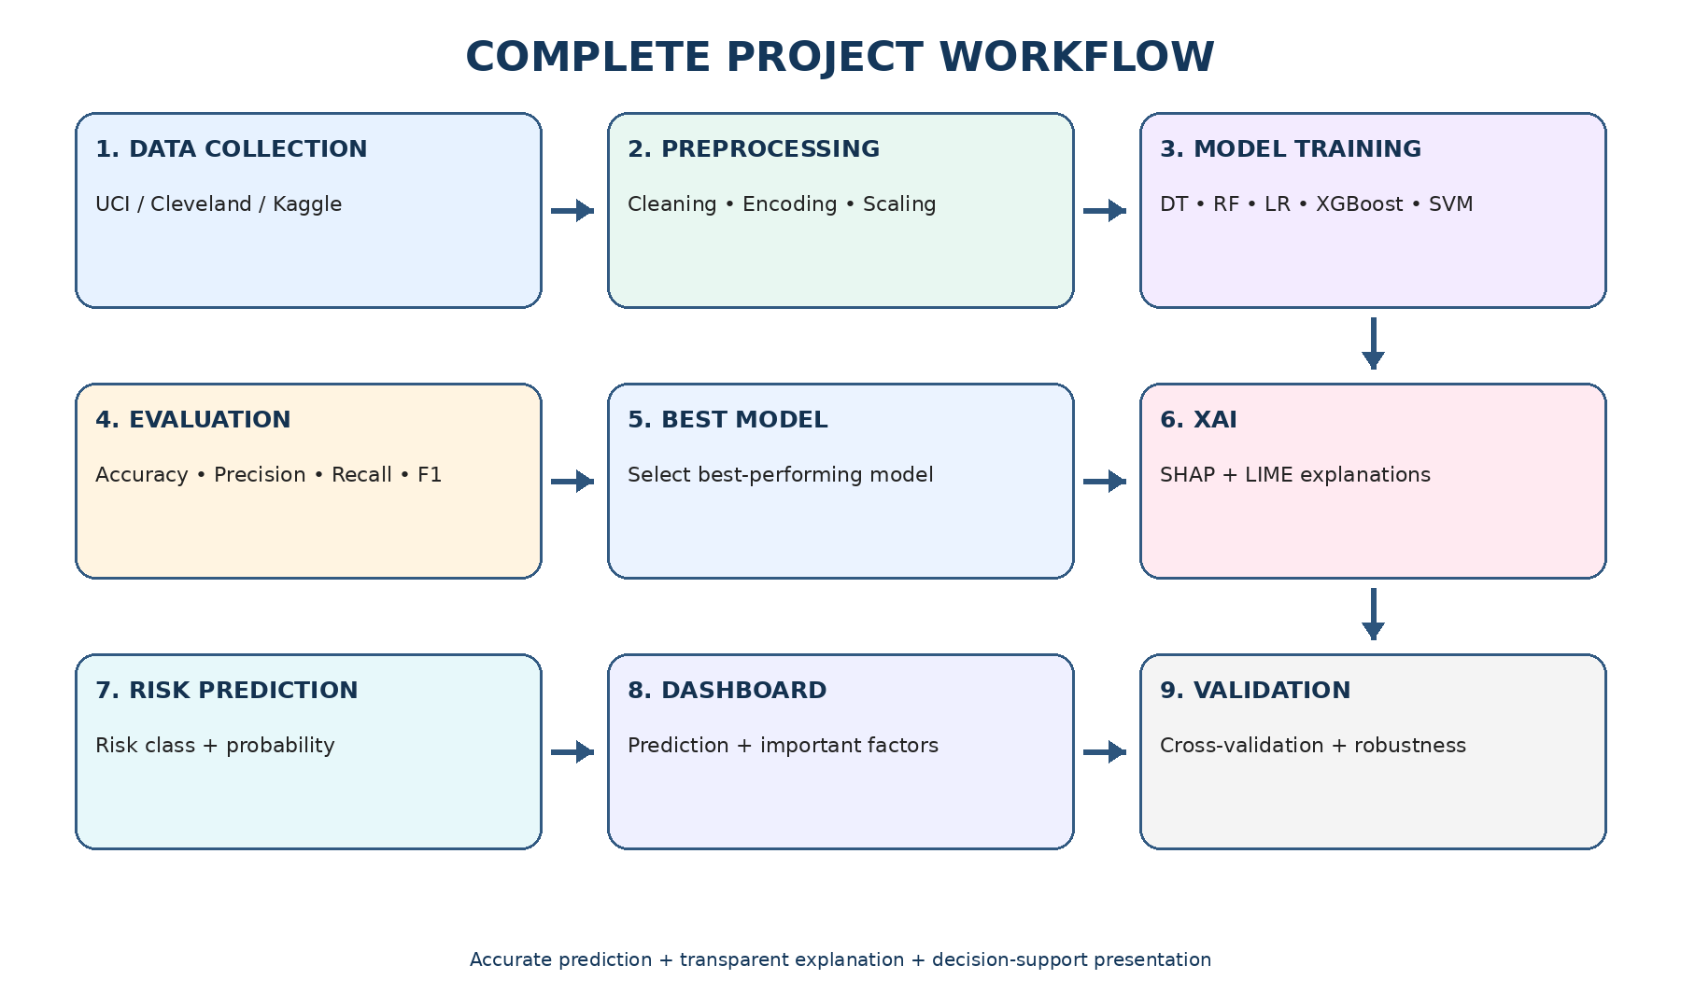
Phase 1 – Dataset Collection: Identify and download suitable public heart disease datasets and select the primary dataset.
Phase 2 – Data Understanding and EDA: Inspect data types, target distribution, missing values, duplicates, outliers and feature relationships.
Phase 3 – Preprocessing: Clean data, handle missing values, encode categorical variables, scale where appropriate and analyse class imbalance.
Phase 4 – Train/Test Design: Create a stratified split and define cross-validation to avoid leakage.
Phase 5 – Model Training: Train DT, RF, LR, XGBoost and SVM using the same experimental protocol.
Phase 6 – Model Evaluation: Compare accuracy, precision, recall, F1, ROC-AUC and confusion matrices.
Phase 7 – Best Model Selection: Select the model using performance, robustness, computational cost and interpretability.
Phase 8 – Explainability: Apply SHAP for global/local feature contributions and LIME for individual predictions.
Phase 9 – Risk Prediction: Generate predicted class/risk and probability for a new patient record.
Phase 10 – Dashboard: Display inputs, risk, probability, important factors and SHAP/LIME explanations.
Phase 11 – Validation: Use cross-validation and, if feasible, an external public dataset; examine explanation consistency.
Phase 12 – Documentation: Record experiments, plots, results, limitations and prepare the final demonstration.
Final execution flow: Public Data → Cleaning → EDA → Encoding/Scaling → Train/Test Split → DT/RF/LR/XGBoost/SVM → Evaluation → Best Model → SHAP + LIME → Risk Prediction → Explanation → Dashboard → Validation

11. Expected Deliverables
- Cleaned dataset
- EDA plots
- Trained ML models and comparison table
- Selected final model
- SHAP global/local plots
- LIME patient-level explanations
- Decision-support dashboard
- Final performance/robustness report
- Project documentation and presentation

12. Expected Outcomes
- Effective early heart disease risk prediction
- Transparent explanations of model decisions
- Identification of influential patient features
- Improved understanding of how XAI can support trust
- A complete workflow that can later be extended to larger and more diverse datasets

13. Key Limitations of the Proposed Project
- Public benchmark datasets may not represent every patient population.
- A model prediction is not a medical diagnosis.
- SHAP/LIME explain model behaviour but do not prove causality.
- Performance may vary across datasets and institutions.
- Clinical deployment requires external validation, privacy/security controls and appropriate approval.

14. Key Dataset Resources
- UCI Machine Learning Repository – Heart Disease Dataset — Open resource
- Kaggle – Heart Disease Dataset — Open resource
- Kaggle – Framingham Heart Study Dataset — Open resource
- PhysioNet – Computing in Cardiology Challenge 2016 — Open resource
- PhysioNet – MIT-BIH Arrhythmia Database — Open resource

